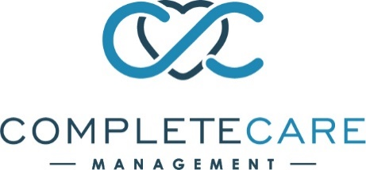
COVID-19 Status

We want you to know that we remain committed to providing upfront and transparent updates regarding COVID-19 in our facility. We will provide an email to our families as information changes and will continue our commination efforts so you can remain as up to date as possible. Rest assured that our staff remains vigilant and supportive, and we are so proud of their loyalty and dedication.
As of today, July 31, 2021, please be advised of the following COVID-19 cases in our facility:
Positive Patients/Residents: 0
Pending Patient/Resident Tests: 0
Positive Staff: 1
Pending Staff Tests: 0

We thank you for your support during this difficult time. Please know, we are adhering to Centers for Disease Control and Prevention (CDC) and Centers for Medicare and Medicaid Services (CMS) guidelines and recommended protocols for COVID-19, in addition to following directives set forth by the New Jersey Department of Health (NJDOH).

If you would like to be added to our email group or for any immediate questions/concerns please contact 732.313.0880.

Thank you,
Complete Care at Inglemoor

